Article for Shelter Magazine

Title: Inclusive Public Spaces for Resilient Economies
Author(s): Rinky Haldar
Abstract:
This paper on "Inclusive Public Spaces for Resilient Economies" underscores the significance of public spaces in nurturing economic resilience within urban environments. Well designed public spaces can contribute to social, psychological and economic benefits in the society. Inclusive public spaces for resilient economies must enable accessibility, diversity, inclusivity, economic opportunities, community interaction, knowledge sharing, physical and psychological well-being, and safety. These spaces foster diversity, encouraging interaction among individuals from varied backgrounds, and they promote inclusivity, addressing the needs of everyone regardless of age, gender, race, or socio-economic status. This article demonstrate the societal and economic value of public spaces when designed from the perspective of youth in India.
Keywords: Inclusion, Sustainable Urban Development, Sustainable Development Goals, Resilient Cities, Integrated Planning, Youth Development, Youth Bulge, Youth Participation, Resilient economies
Rinky Haldar (rinky.haldar@un.org); is Urban Planner, UN-Habitat India

Introduction:
In our rapidly evolving world, the concept of resilience has taken on fundamental importance. It's not merely about bouncing back from challenges but also about fortifying ourselves against future uncertainties. One critical arena where resilience takes root and thrives is within our cities, the bustling centers of human activity and innovation.
The year 2023 has posed its unique set of trials, testing the mettle of cities around the globe. Economic growth has encountered a downturn globally, bringing it to a sluggish 2.5% (IMF, 2023). This rate of growth, except for the significant jolts of 2009 and 2020, has not occurred since 2001. In this context, the fate of nations hinges on the productivity of their urban domains, often referred to as the engines of growth (UN-Habitat, 2022).
Cities, indeed, are the crucibles where economic value is generated, and it's this value that propels growth and recovery. But for growth to be not just robust but also sustainable, cities must possess a unique quality – resilience. They must have the capacity to absorb shocks, rebound from adversity, and brace themselves for the economic and environmental storms of the future. In recognition of these imperatives, UN-Habitat initiated the Global Public Space Program in 2012. One of its central objectives is to assist governments in crafting socially inclusive public spaces. These spaces aren't merely physical; they are where communities forge bonds and resilience takes root.
In this article, we delve into the tangible and intangible dividends of inclusive public spaces. We explore their role as epicenters for economic vitality and community cohesion. And we narrate the role of a specific set of stakeholders whose lives have been transformed by these spaces, revealing how they hold the key not just to recovery but also to sustained growth in our cities.
Urbanization and Leveraging Youth Dividend
Urbanization in the 21st century is undeniably the driving force propelling the world toward prosperity, and at the helm of this transformative process are the world's youth. Young people represent society's most essential and dynamic human resource. In the contemporary landscape, there are more individuals under the age of 25 than ever before, a staggering figure approaching three billion, which equates to almost half of the world's total population. Among this youth demographic, 1.3 billion falls within the age range of 12 to 24 (World Bank, 2006). These young people predominantly reside in urban centers, constituting a significant portion of urban populations. Notably, it is in the cities of the developing world where urbanization is most pronounced, accounting for over 90% of the world's urban growth. Within these burgeoning urban landscapes, youth comprise a substantial segment of the population.
By the end of this decade, projections indicate that the influence of youth in urban areas will continue to grow. It is estimated that by 2030, an astonishing 60% of all urban dwellers will be under the age of 18 (Woodrow Wilson International Center for Scholars, 2003). This demographic shift is poised to reshape the social, economic, and cultural fabric of our cities, making it imperative that the voices, aspirations, and contributions of young people are recognized, respected, and integrated into the planning and development of urban spaces. Furthermore, a staggering 70% of the global population will be under the age of 30. This youth majority holds immense potential for innovation, creativity, and economic growth. A concerning aspect of this demographic change is that more than 70% of the population residing in slums and informal settlements will comprise young people. These areas often grapple with inadequate infrastructure, limited access to education and healthcare, and economic disparities.
In light of these statistics, it is evident that young people are not just the future but also the present. Empowering them, listening to their perspectives, and involving them in shaping the world's future are essential steps toward achieving sustainable development and inclusive societies. Addressing the needs and aspirations of youth is crucial for harnessing their energy, talents, and creativity to build a better world for all.
India’s Youth Bulge
India has its largest ever adolescent and youth population. According to UNFPA projections, India will continue to have one of the youngest populations in the world till 2030. India is experiencing a demographic window of opportunity, a “youth bulge” that will last till 2025. India’s youth face several development challenges, including access to education, gainful employment, gender inequality, child marriage, youth-friendly health services and adolescent pregnancy. Yet, with investments in their participation and leadership, young people can transform the social and economic fortunes of the country. With nearly one out of every four persons between the ages of 15 and 29, India has an enviable youth population (India Draft National Youth Policy, 2021). Currently, they are estimated to constitute more than 34% of the total population. While these numbers are expected to decline in the coming years, youth will still account for almost 24% of India’s population or 365 million people in 2030. Compared to countries like China, Japan, and the USA, where they face the challenge of an ageing population, India has the advantage of being in a position of strength with the potential to drive economic growth.
The youth bulge can be viewed as a demographic dividend, representing a potentially valuable economic resource. When properly educated, skilled, and employed, this youthful workforce can contribute significantly to economic growth and development. While the youth bulge presents opportunities, it also poses challenges. India must create sufficient educational and employment opportunities to harness the potential of its young population. Failing to do so could result in high youth unemployment and underutilization of human capital.
Global Landscape of Youth Challenges
The youth demographic presents both opportunities and challenges across the world. Here are key points highlighting the global situation of youth:
Youth in Developing Countries: - 09 out of every 10 young people between the ages of 10 to 24 reside in developing countries. These regions often grapple with issues such as poverty, inadequate healthcare, limited access to quality education, and a higher incidence of conflict and violence. This can hinder the well-being and development of young people.
Unprecedented Youth Population: - The world is currently experiencing an unprecedented surge in its youth population. There have never been so many young people on the globe before. This demographic surge represents a unique opportunity for economic and social progress, as young people possess the potential to drive innovation, productivity, and positive change.
Realizing the Demographic Dividend: - To fully harness the potential of this youth population, governments and societies must recognize and act upon the demographic dividend. This concept underscores the economic benefits that can be reaped when a large proportion of the population is of working age and productive, provided that sufficient investments are made in education, skills development, and job creation.
Youth Unemployment: - Despite the demographic dividend's potential, youth unemployment remains a pressing global issue. High levels of youth unemployment are observed not only in developing countries but also in developed nations. This can lead to social and economic challenges, including reduced economic growth and opportunities for young people.
Efforts to address these challenges often involve policies and programs aimed at improving access to education, vocational training, and job opportunities for youth. Empowering young people with the skills, resources, and opportunities they need to succeed is essential for realizing the demographic dividend and fostering positive social and economic outcomes.
Share of Youth Not in Education, Employment or Training (NEET), 2021
The global NEET (The share of youth not in education, employment, or training) rate for young people between the ages of 15 and 24 was estimated to be around 13.9% in 2021. This means that approximately 13.9% of young people in this age group were not engaged in education, employment, or training. In developing countries, there is a notable proportion of young people who are not engaged in education, employment, or training. This phenomenon reflects a range of socioeconomic challenges.
The share of youth not in education, employment, or training (NEET) is a significant concern in many parts of the world, particularly in developing countries like India. In India, it is indeed alarming that more than 30% of the youth fall into the NEET category, indicating a substantial portion of young people facing challenges in accessing education and employment opportunities. The National Sample Survey Office (NSSO) in India conducted surveys that shed light on the NEET situation in the country; In urban areas, 27% of individuals aged 15-24 were not in education, employment, or training at the time of the survey and only 39.4% of individuals aged 15-29 in urban areas were involved in formal and non-formal education and training in the 12 months preceding the survey. Access to mobile phones with active SIM cards was relatively high, with 83.7% of individuals aged 18 and above in urban areas and 67.8% in rural areas using mobile phones in the three months prior to the survey.
These findings highlight the need for targeted efforts to address the NEET issue in India, including improving access to education and training opportunities, enhancing digital access, and creating employment prospects for young people. High NEET rates can have long-term social and economic implications, making it essential for policymakers and stakeholders to address this challenge effectively.
Cities and Communities of the Youth
Cities and communities with active youth engagement are vibrant and dynamic spaces that recognize the importance of involving young people in shaping their future. Few of highlighted characteristics of Cities and Communities with Active Youth Engagement are as follows: -
- Inclusive Decision-Making: These cities prioritize inclusivity in decision-making processes, ensuring that youth voices are heard and valued. Young people actively participate in local governance, policy development, and community initiatives.
- Youth-Friendly Policies: These communities implement youth-friendly policies that address the unique needs and aspirations of young residents. This may include support for youth employment, education, healthcare, and recreational opportunities.
- Youth-Driven Initiatives: They encourage and support youth-led initiatives and organizations that address local challenges. These initiatives range from community development projects to social enterprises and advocacy campaigns.
- Safe and Accessible Public Spaces: These cities provide safe and accessible public spaces where young people can gather, socialize, and engage in various activities. Public spaces play a crucial role in fostering community connections and promoting positive youth interactions.
- Education and Skill Development: They invest in education and skill development programs that equip young people with the knowledge and skills needed for meaningful employment and civic engagement.
- Youth Entrepreneurship: These communities promote youth entrepreneurship by providing resources and mentorship to young entrepreneurs. This supports economic growth and job creation.
- Cultural Diversity and Inclusivity: They celebrate cultural diversity and encourage cultural exchange and integration among young people from different backgrounds. This fosters tolerance and understanding.
- Community Safety: Ensuring the safety of young people is a priority. Strategies to reduce crime and violence, particularly in disadvantaged areas, are actively pursued.
Here, we'll explore what such cities and communities look like and the benefits of youth-led development through a case study from Nairobi, Kenya.
Young and disadvantaged in Kenya: The Case of the Mathare Slum in Nairobi

Kenya, with a population estimated to have reached 46 million in 2015, is projected to grow to 60 million by 2030. A significant portion of this population comprises young people aged 15-34, representing over 35% of the total population. Nairobi, the capital of Kenya, is home to a complex urban landscape that includes some of Africa's oldest and largest slums, facing multifaceted socio-economic and infrastructural challenges. Among these challenges are unemployment, insufficient waste management systems, and a growing informal housing sector.

The Mathare Slum:
Background: Mathare, situated in Nairobi, is one of the most notable slums in the city. It was established on top of a waste dump and is the second largest and oldest slum in Nairobi. The majority of its residents live in wooden and tin shacks, contributing to its high population density. Mathare is subdivided into several wards, with each ward forming a distinct community and electoral constituency. The study focuses on Mlango Kubwa, a ward within Mathare, which is home to approximately 38,000 inhabitants. Notably, Mlango Kubwa, has seen significant improvements in recent years, largely due to the efforts of the Mathare Environmental Conservation Youth Group (MECYG).

MECYG, established in 1997, started as a response to the challenges facing the community, including waste management and high youth unemployment. Over the years, the group has grown to around 40 active members and has engaged approximately 150-200 children and youth in various activities. MECYG's work has had several positive impacts on Mlango Kubwa:

- Waste Management: MECYG initiated a waste management system, employing young people to collect garbage from households. This not only improved cleanliness but also created employment opportunities for youth.
- Public Space: MECYG advocated for and built a youth center and soccer field on publicly owned land, providing a safe and accessible space for young people.
- Enhanced Security: MECYG and other youth groups addressed security issues, leading to improved safety in the community through patrolling and crime prevention efforts.

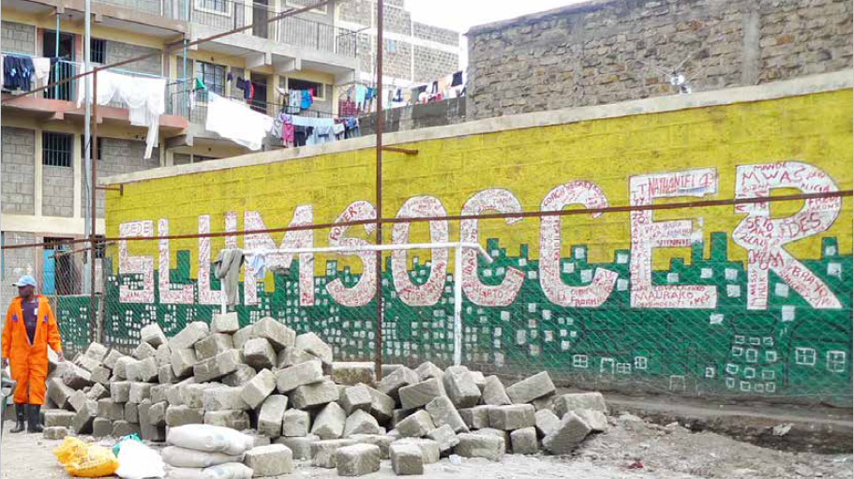
Image 1 Work Of Mathare Environmental Conservation Youth Group (MECYG)
The Mathare slum's experience underscores the importance of grassroots youth-led initiatives in addressing the challenges faced by disadvantaged communities. When young people are empowered to take action and are provided with opportunities for economic and social development, they can make significant strides in improving their living conditions and fostering positive change in their communities. The Mathare case serves as an example of resilience and community-driven progress in the face of adversity.

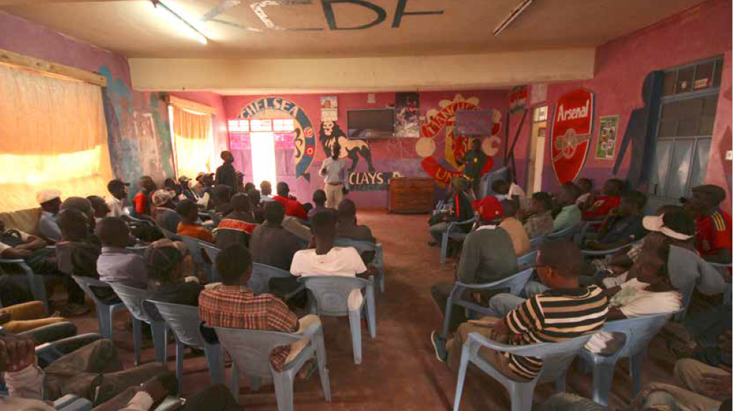
Image 2 Work Of Mathare Environmental Conservation Youth Group (MECYG)
Overall, cities and communities that prioritize youth engagement and development are better positioned to address current and future challenges while fostering a sense of ownership and belonging among young residents.

Learnings from UN-Habitat’s Urban Youth Fund
UN-Habitat's Urban Youth Fund is one of the United Nations' longest-running youth programs, designed to support youth-led initiatives focused on urban development and community improvement. Over the years, this program has yielded valuable insights and learnings:
- Youth-Led Development: - The Urban Youth Fund promotes a youth-led development approach. It recognizes the creativity, innovation, and agency of young people, positioning them as active contributors to community development rather than passive beneficiaries of aid.
- Bottom-Up Approach: - By supporting youth-led initiatives, the fund emphasizes a bottom-up approach to development. This approach empowers young people to identify and address local challenges and solutions, ensuring that interventions are contextually relevant and sustainable.
- Economic Empowerment: - Adequate funding for youth-led development can result in the creation of viable businesses and social enterprises. These initiatives contribute to self-sustainability, job creation, and economic growth while fostering peer-to-peer support and strengthening social capital and trust.
- Innovation and Effectiveness: - The Urban Youth Fund serves as a laboratory for testing and identifying innovative and effective practices for youth-led empowerment. It encourages experimentation and learning to discover what works best in different urban contexts.
- Input to Normative Work: - The fund provides valuable input to UN-Habitat's normative work on youth empowerment and sustainable urban development. The insights gained from funded projects inform policy recommendations and guidelines, contributing to better practices in urban planning and governance.
- Access to Resources: - Participating youth-led initiatives gain access to essential resources such as working space, land, materials, and equipment. These resources are critical for implementing projects and scaling up their impact.
- Capacity Building: - The fund supports capacity-building initiatives focused on job creation and entrepreneurship. It equips young people with the skills and knowledge needed to develop and manage their projects successfully.
- Community Collaboration: - Funded projects often involve collaboration with local communities, fostering cooperation and mutual support. This strengthens community ties and encourages collective action.
- Youth Networks: - The program encourages the development of youth networks, discussion forums, groups, and resource centers. These platforms facilitate knowledge sharing, peer learning, and collaboration among young people and their communities.
- External Partnerships: - Engagement with external partners, including governmental and non-governmental organizations, is vital for project success. The Urban Youth Fund enhances partnerships and external funding opportunities, expanding the impact of youth-led initiatives.
- Sustainable Employment: - The fund's support for youth-led social enterprises and businesses contributes to the creation of sustainable youth employment. It aligns with the goal of reducing youth unemployment and underemployment in urban areas.
- Inclusive Development: - By focusing on youth-led initiatives, the fund promotes inclusive development that considers the needs and aspirations of young people from diverse backgrounds, ensuring that no one is left behind.
In conclusion, UN-Habitat's Urban Youth Fund demonstrates the transformative potential of youth-led development initiatives. By providing resources, capacity building, and support for young entrepreneurs and activists, the program empowers youth to address urban challenges and contribute to the sustainable development of their communities. It offers valuable lessons on how to engage and invest in youth for the betterment of cities and societies.
Benefits of public spaces for youth
Public spaces provide a multifaceted environment that contributes positively to the lives of young people. They offer opportunities for physical and mental well-being, social interaction, skill development, and community engagement, ultimately enhancing the quality of life for youth and the communities they belong to. Here's a closer look at these advantages: -
- Economic Benefits:
  - Job Opportunities: Public spaces can create employment opportunities for young people. They can find work as park attendants, event organizers, or in various roles related to the maintenance and management of these spaces.
  - Formal and Informal Economic Activities: Public spaces often serve as venues for both formal and informal economic activities. This includes the operation of food trucks, artisan markets, pop-up shops, open workshops, and more, allowing youth to start or run businesses.
  - Community Economic Activities: Public spaces can stimulate economic activity within the community, benefiting local businesses, entrepreneurs, and artisans.
- Social Benefits:
  - Reduced Spatial Inequalities: Inclusive public spaces can help reduce spatial inequalities by providing equal access to recreational and economic opportunities for youth across different neighborhoods and backgrounds.
  - Improved Community Interactions: Public spaces encourage community members, including youth, to interact and build social bonds, fostering a sense of belonging and unity.
  - Knowledge Sharing: These spaces often serve as hubs for knowledge sharing, whether through workshops, cultural events, or informal gatherings, providing opportunities for youth to learn and grow.
- Psychological Benefits:
  - Reduced Depression and Anxiety: Access to public spaces and engagement in activities can reduce feelings of depression and anxiety among youth. These spaces offer a respite from daily stressors.
  - Increased Physical Activity: Public spaces with recreational facilities encourage physical activity, promoting better physical and mental health among young people.
  - Improved Safety: Well-maintained and vibrant public spaces help reduce crime rates and the fear of crime, enhancing the overall safety and well-being of the community.
Inclusive public spaces indeed play a vital role in fostering economic development, social cohesion, psychological well-being, and inclusivity for youth, making them valuable assets for communities and cities.
Economic resilience, especially in the context of youth-led initiatives in public spaces, can have a significant positive impact on both individuals and their communities. Here are specific examples of economic resilience initiatives:
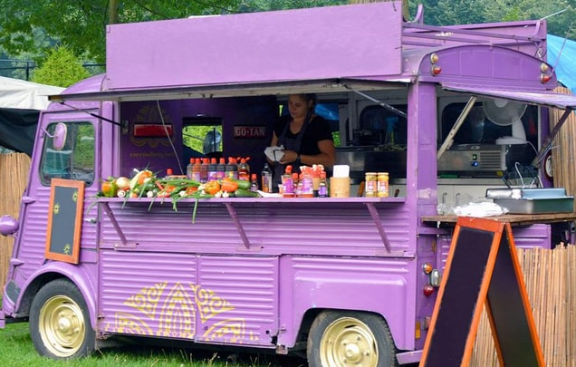
- Food Trucks: Example: The story of the 20-year-old Vadodara boy who set up a street stall and received support from the internet demonstrates how young entrepreneurs can start businesses, like food trucks, that not only provide economic opportunities for themselves but also add vibrancy to public spaces. Food trucks often offer unique and affordable dining options, attracting customers and contributing to the local economy.
Image 3 Youths with special needs run mobile food truck.
- Artisan Markets: Impact: Artisan markets provide a platform for local artisans and craftspeople, including youth, to showcase and sell their handmade products. These markets not only promote economic self-sufficiency but also preserve traditional crafts and cultural heritage.
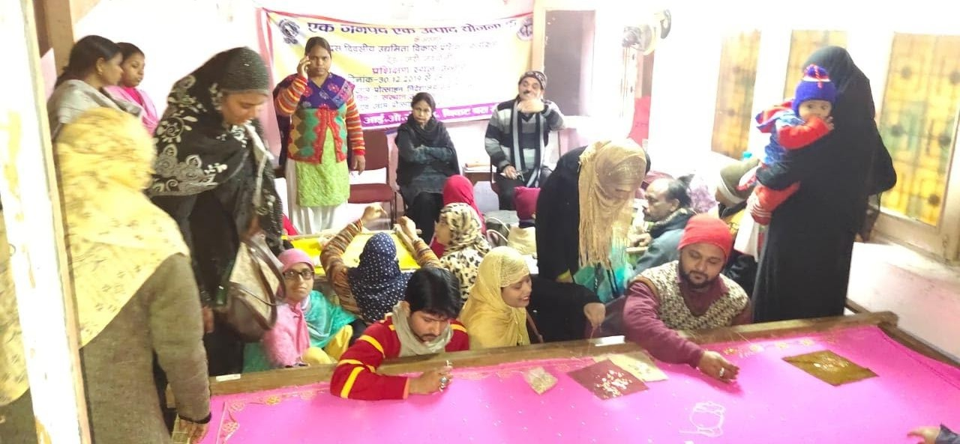
Image 4 Unnao’s model for transforming Art into Sustainable Livelihoods
- Pop-Up Shops: Example: Pop-up shops, like street stalls, can be set up by young entrepreneurs in public spaces. They offer a flexible and temporary retail model, allowing youth to test their business concepts, connect with customers, and generate income.
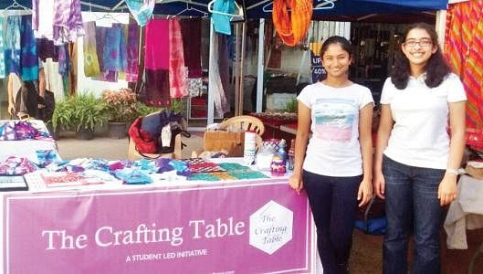
Image 5 Create temporary retail spaces for young entrepreneurs to showcase their products.
- Open Workshops in Public Spaces: Impact: Public spaces can host open workshops where young people can teach or learn new skills, from arts and crafts to technology and vocational training. These workshops promote entrepreneurship, creativity, and skill development.
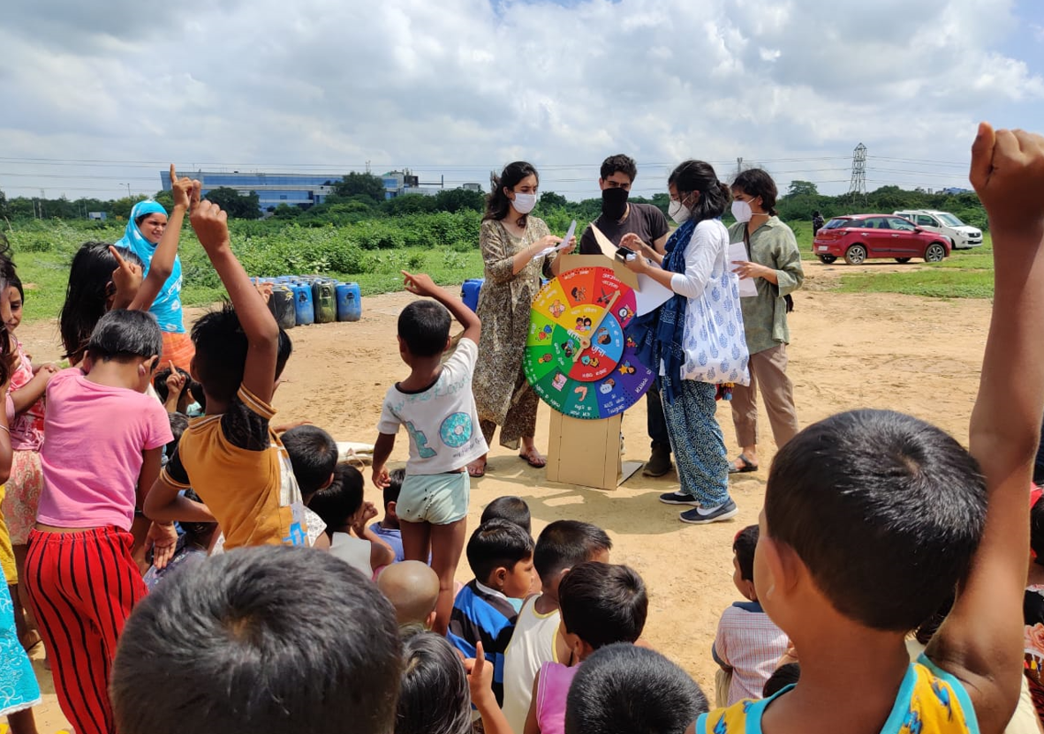
Image 6 Youth-led movement ‘Baatein Unlocked’ launched across three Indian states
- Entertainment and Performance: Example: Street performers and entertainers, often youth, use public spaces to showcase their talents. They can earn income through tips or donations from passersby, supporting their artistic pursuits while enlivening public areas.

Image 7 Provide a stage or platform for young performers, musicians, and artists, Host concerts, open mic nights, and artistic showcases.
- Eco-Friendly Initiatives: Impact: Initiatives focused on sustainability and environmental conservation, such as recycling programs, tree planting, and waste reduction efforts, can create green jobs for youth. These initiatives contribute to both economic and environmental resilience.
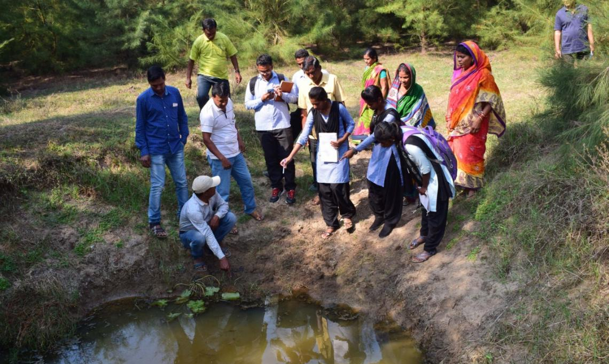
Image 8 Community and youth led action climate change and conservation.
- Fitness and Wellness Services: Impact: Public parks and recreational spaces offer opportunities for young fitness trainers and wellness practitioners to provide services such as fitness classes, yoga sessions, and personal training. This not only promotes healthier lifestyles but also creates income-generating opportunities for youth.
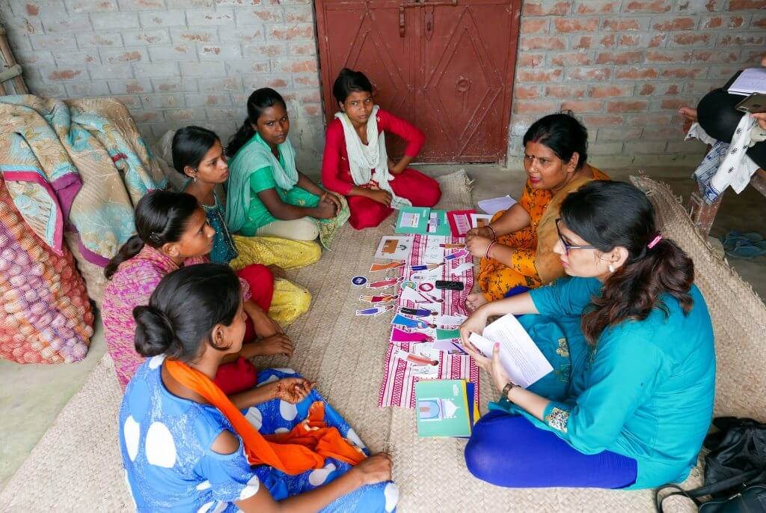
Image 9 Promote physical and mental well-being in the community
- Technological and Digital Services: Impact: Public spaces equipped with technology hubs, free Wi-Fi, and digital services can serve as centers for digital skill development and internet-based businesses. Young entrepreneurs can offer services like web design, social media management, or online tutoring.
- Community Gardening and Farming: Examples: Initiatives like urban farming, community gardens, and nutrition gardens, as demonstrated by Aman Sharma in Delhi, empower youth to grow produce and contribute to food security. Surplus produce can be sold, generating income for young farmers.
- Tutoring and Lessons for Younger Kids: Impact: Young people can offer tutoring and lessons to younger children in public spaces, providing educational support. These initiatives not only help younger students but also create opportunities for youth to earn income through teaching.
These examples illustrate how public spaces can serve as fertile ground for youth-led economic initiatives that enhance resilience, foster entrepreneurship, and contribute to the economic well-being of both individuals and their communities. They demonstrate the potential of youth to create economic opportunities and positively impact their surroundings. Our cities must prioritize developing and investing in vibrant public spaces to stimulate local economic development and provide spaces for youth to unleash their potential as contributors to a thriving society.

International Labour Organization (via World Bank)
https://www.ndtv.com/food/20-year-old-vadodara-boy-sets-up-street-stall-internet-gives-full-support-4374853
https://www.ndtv.com/food/20-year-old-vadodara-boy-sets-up-street-stall-internet-gives-full-support-4374853
https://timesofindia.indiatimes.com/india/busking-or-begging-how-india-sees-its-street-performers/articleshow/102698100.cms?from=mdr
https://www.thebetterindia.com/307010/aman-sharma-delhi-teenager-grows-urban-jungle-terrace-garden-birding-wildlife-climate-change/
https://www.orfonline.org/research/nutrition-gardens-a-sustainable-model-for-food-security-and-diversity-67933/
https://www.unicef.org/india/stories/greening-blues-my-journey-young-changemaker

